# UseNeural network

## Artificial Neural Network (ANN)?

An artificial neural network (ANN) is the piece of a computing system designed to simulate the way the human brain analyzes and processes information. It is the foundation of [artificial intelligence](https://www.investopedia.com/terms/a/artificial-intelligence-ai.asp) (AI) and solves problems that would prove impossible or difficult by human or statistical standards. ANNs have self-learning capabilities that enable them to produce better results as more data becomes available.

**KEY TAKEAWAYS**

An artificial neural network (ANN) is the component of artificial intelligence that is meant to simulate the functioning of a human brain.

Processing units make up ANNs, which in turn consist of inputs and outputs. The inputs are what the ANN learns from to produce the desired output.

Backpropagation is the set of learning rules used to guide artificial neural networks.

The practical applications for ANNs are far and wide, encompassing finance, personal communication, industry, education, and so on.

**Basic concept of neural network**

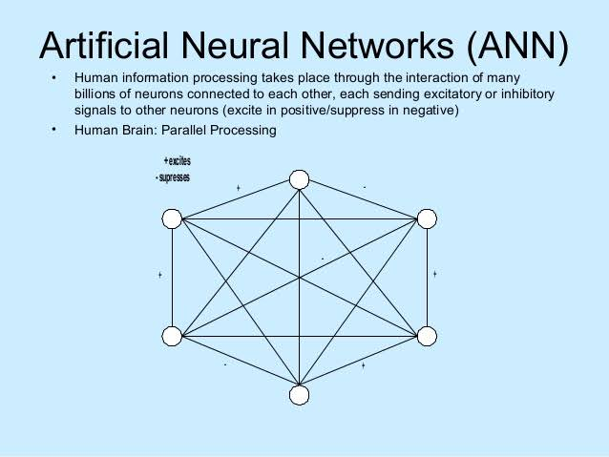

**Artificial neural networks** are built like the human brain, with neuron nodes interconnected like a web. The human brain has hundreds of billions of cells called neurons. Each neuron is made up of a cell body that is responsible for processing information by carrying information towards (inputs) and away (outputs) from the brain

An ANN has hundreds or thousands of artificial neurons called processing units, which are interconnected by nodes. These processing units are made up of input and output units. The input units receive various forms and structures of information based on an internal weighting system, and the neural network attempts to learn about the information presented to produce one output report. Just like humans need rules and guidelines to come up with a result or output, ANNs also use a set of learning rules called backpropagation, an abbreviation for backward propagation of error, to perfect their output results.

**Inference and learning**:

Inference

In artificial intelligence, we need intelligent computers which can create new logic from old logic or by evidence, so generating the conclusions from evidence and facts is termed as Inference.

Inference rules:

Inference rules are the templates for generating valid arguments. Inference rules are applied to derive proofs in artificial intelligence, and the proof is a sequence of the conclusion that leads to the desired goal.

**Learning**

Learning is one of the fundamental building blocks of artificial intelligence (AI) solutions. From a conceptual standpoint, learning is a process that improves the knowledge of an AI program by making observations about its environment. From a technical/mathematical standpoint, AI learning processes focused on processing a collection of input-output pairs for a specific function and predicts the outputs for new inputs. Most of the artificial intelligence(AI) basic literature identifies two main groups of learning models: supervised and unsupervised. However, that classification is an oversimplification of real world AI learning models and techniques.